**SAVITRIBAI PHULE PUNE UNIVERSITY**

**A PRELIMINARY MINI PROJECT ON**

**Client-Server Architecture Based E-Mail System.**

SUBMITTED TOWARDS THE

PARTIAL FULFILLMENT OF THE REQUIREMENTS OF

**Bachelor of Engineering (Computer Engineering)**

**BY**

Yash Garudkar 55

Anushree Sisodia 14

Mohit Sonawane 74

**Under the Guidance of**

Prof. Kanchan Mahajan



DEPARTMENT OF COMPUTER ENGINEERING

**Sandip Foundation,**

**Sandip Institute of Technology & Research Centre, Nashik (2019-20)**



**Sandip Foundation,**

**Sandip Institute of Technology & Research Centre, Nashik (2019-20)**

DEPARTMENT OF COMPUTER ENGINEERING

**CERTIFICATE**

This is to certify that the Mini Project Entitled

**Client-Server Architecture Based E-Mail System.**

Submitted by

Yash Garudkar 55

Anushree Sisodia 14

Mohit Sonawane 74

Is a Bonafide work carried out by Students under the supervision of Prof. Pramod Patil and it is submitted towards the partial fulfillment of the requirement of Fourth Year of Engineering (Computer Engineering) Mini Project.

Prof. Pramod Patil Prof. AMOL POTGANTWAR

Internal Guide H.O.D

Dept. of Computer Engineering. Dept. of Computer Engineering.

***Acknowledgments***

*It gives us great pleasure in presenting the mini project on “****Job Posting Site”***

*I would like to take this opportunity to thank my internal guide Prof. Pramod Patil Sir for giving me all the help and guidance I needed. I am grateful to them for their kind support. Their valuable suggestions were very helpful.*

*I am also grateful to Prof. Amol Potgantwar, Head of Computer Engineering Department, Sandip Institute of Technology & Research Centre, Nashik for his indispensable support, suggestions, for Our Project.*

Yash Garudkar

Mohit Sonawane

Anushree Sisodia

(B.E. Computer Engineering.)

**1.1** Introduction

Mailing services gives free web based electronic mail.Mailing Services enables you to acquire new customers and to increase growth opportunities with existing customers. With a wide range of Direct Mail Lists Services, label mailing or mail merge services, we enable you to communicate with customers in a better way.

**Aim-:** The main aim of our project is to provide a mailing services which lets you compose mail and send to a respective selected object. You can send documents or images (attachments). Also, one can search emails with the search technology within the inbox, outbox, drafts.

**Objective-:** To prepare new mailing system on PHP which provide all the services provide by any general mailing services with some extra features such as easy to operate ,free messaging services are objective to make this project at very huge level but we just learn how to make mailing service system we are able in future to work over this project easily and provide much better facilities. So here we are showing you dummy project on mailing services prepared with help of PHP and some other designing tools.

**Vision-:** Our vision for this project and training is to build and maintains a customer-oriented culture. The customer satisfaction is what we aspire for. Hence, we are to provide a mailing service that is easy and comfortable to control and function with certain additional facilities.

|  |  |
| --- | --- |
|  | |
|  |  |
|  | PHP  PHP: Hypertext Preprocessor, is a widely used, general-purpose [scripting language](http://en.wikipedia.org/wiki/Scripting_language) that was originally designed for [web development](http://en.wikipedia.org/wiki/Web_development), to produce [dynamic web pages](http://en.wikipedia.org/wiki/Dynamic_web_page). It can be embedded into [HTML](http://en.wikipedia.org/wiki/HTML) and generally runs on a [web server](http://en.wikipedia.org/wiki/Web_server), which needs to be configured to process PHP code and create [web page](http://en.wikipedia.org/wiki/Web_page) content from it. It can be deployed on most web servers and on almost every [operating system](http://en.wikipedia.org/wiki/Operating_system) and [platform](http://en.wikipedia.org/wiki/Platform_(computing)) free of charge.  PHP was originally created by [Rasmus Lerdorf](http://en.wikipedia.org/wiki/Rasmus_Lerdorf) in [1995](http://en.wikipedia.org/wiki/1995) and has been in continuous development ever since. The main implementation of PHP is now produced by The PHP Group and serves as the [de facto standard](http://en.wikipedia.org/wiki/De_facto_standard) for PHP as there is no [formal specification](http://en.wikipedia.org/wiki/Formal_specification). PHP is [free software](http://en.wikipedia.org/wiki/Free_software) released under the [PHP License](http://en.wikipedia.org/wiki/PHP_License), which is incompatible with the [GNU General Public License](http://en.wikipedia.org/wiki/GNU_General_Public_License) (GPL) because of restrictions on the use of the term PHP  PHP has evolved to include a [command line interface](http://en.wikipedia.org/wiki/Command_line_interface) capability and can also be used in [standalone](http://en.wikipedia.org/wiki/Standalone_software) [graphical applications](http://en.wikipedia.org/wiki/Graphical_user_interface).  **USAGE**  PHP is a general-purpose scripting language that is especially suited for [web development](http://en.wikipedia.org/wiki/Web_development). PHP generally runs on a [web server](http://en.wikipedia.org/wiki/Web_server). Any PHP code in a requested file is [executed](http://en.wikipedia.org/wiki/Execution_(computing)) by the PHP runtime, usually to create [dynamic web page](http://en.wikipedia.org/wiki/Dynamic_web_page) content. It can also be used for [command-line](http://en.wikipedia.org/wiki/Command-line) scripting and [client-side](http://en.wikipedia.org/wiki/Client-side) [GUI](http://en.wikipedia.org/wiki/Graphical_user_interface) applications. PHP can be deployed on most [web servers](http://en.wikipedia.org/wiki/Web_server), many [operating systems](http://en.wikipedia.org/wiki/Operating_system) and [platforms](http://en.wikipedia.org/wiki/Platform_(computing)), and can be used with many [relational database management systems](http://en.wikipedia.org/wiki/Relational_database_management_system). It is available free of charge, and the PHP Group provides the complete source code for users to build, customize and extend for their own use.  PHP primarily acts as a [filter](http://en.wikipedia.org/wiki/Filter_(software)), taking input from a file or stream containing text and/or PHP instructions and outputs another stream of data; most commonly the output will be HTML. Since PHP 4, the PHP [parser](http://en.wikipedia.org/wiki/Parser) [compiles](http://en.wikipedia.org/wiki/Compiler) input to produce [byte code](http://en.wikipedia.org/wiki/Bytecode) for processing by the [Zend Engine](http://en.wikipedia.org/wiki/Zend_Engine), giving improved performance over its [interpreter](http://en.wikipedia.org/wiki/Interpreter_(computing)) predecessor  Originally designed to create dynamic web pages, PHP now focuses mainly on [server-side scripting](http://en.wikipedia.org/wiki/Server-side_scripting), and it is similar to other server-side scripting languages that provide dynamic content from a web server to a [client](http://en.wikipedia.org/wiki/Client_(computing)), such as [Microsoft](http://en.wikipedia.org/wiki/Microsoft)'s [Active Server Pages](http://en.wikipedia.org/wiki/Active_Server_Pages), [Sun Microsystems](http://en.wikipedia.org/wiki/Sun_Microsystems)' [JavaServer Pages](http://en.wikipedia.org/wiki/JavaServer_Pages) and [mod_perl](http://en.wikipedia.org/wiki/Mod_perl). PHP has also attracted the development of many [frameworks](http://en.wikipedia.org/wiki/Software_framework) that provide building blocks and a design structure to promote [rapid application development](http://en.wikipedia.org/wiki/Rapid_application_development) (RAD). Some of these include [CakePHP](http://en.wikipedia.org/wiki/CakePHP), [Symfony](http://en.wikipedia.org/wiki/Symfony), [CodeIgniter](http://en.wikipedia.org/wiki/CodeIgniter), and [Zend Framework](http://en.wikipedia.org/wiki/Zend_Framework), offering features similar to other [web application frameworks](http://en.wikipedia.org/wiki/List_of_web_application_frameworks).  **About HTML**  **HTML**, which stands for **Hyper Text Markup Language**, is the predominant [markup language](http://en.wikipedia.org/wiki/Markup_language) for [web pages](http://en.wikipedia.org/wiki/Web_page). It provides a means to create [structured documents](http://en.wikipedia.org/wiki/Structured_document) by denoting structural [semantics](http://en.wikipedia.org/wiki/Semantic) for text such as headings, paragraphs, lists etc as well as for links, quotes, and other items. It allows [images and objects](http://en.wikipedia.org/wiki/HTML_element#Images_and_objects) to be embedded and can be used to create [interactive forms](http://en.wikipedia.org/wiki/HTML_element#Forms). It is written in the form of [HTML elements](http://en.wikipedia.org/wiki/HTML_element) consisting of "tags" surrounded by [angle brackets](http://en.wikipedia.org/wiki/Brackets#Angle_brackets_or_chevrons_.3C_.3E) within the web page content. It can include or can load [scripts](http://en.wikipedia.org/wiki/Scripting_language) in languages such as [JavaScript](http://en.wikipedia.org/wiki/JavaScript) which affect the behavior of HTML processors like [Web browsers](http://en.wikipedia.org/wiki/Web_browser); and [Cascading Style Sheets](http://en.wikipedia.org/wiki/Cascading_Style_Sheets) (CSS) to define the appearance and layout of text and other material. The [W3C](http://en.wikipedia.org/wiki/W3C), maintainer of both HTML and CSS standards, encourages the use of CSS over explicit presentational markup.  Hyper Text Markup Language(HTML) is the encoding scheme used to create and format a web document. A user need not be an expert programmer to make use of HTML for creating hypertext documents that can be put on the internet.  Most graphical [e-mail](http://en.wikipedia.org/wiki/E-mail) clients allow the use of a subset of HTML (often ill-defined) to provide formatting and [semantic](http://en.wikipedia.org/wiki/Semantic_web) markup not available with [plain text](http://en.wikipedia.org/wiki/Plain_text). This may include typographic information like coloured headings, emphasized and quoted text, inline images and diagrams. Many such clients include both a [GUI](http://en.wikipedia.org/wiki/GUI) editor for composing HTML e-mail messages and a rendering engine for displaying them. Use of HTML in e-mail is controversial because of compatibility issues, because it can help disguise [phishing](http://en.wikipedia.org/wiki/Phishing) attacks, because it can confuse [spam](http://en.wikipedia.org/wiki/E-Mail_spam) filters and because the message size is larger than plain text.  **NAMING CONVENTIONS**  The most common [filename extension](http://en.wikipedia.org/wiki/Filename_extension) for [files](http://en.wikipedia.org/wiki/Computer_file) containing HTML is .html. A common abbreviation of this is .htm, which originated because some early operating systems and file systems, such as [DOS](http://en.wikipedia.org/wiki/DOS) and [FAT](http://en.wikipedia.org/wiki/File_Allocation_Table), limited file extensions to [three letters](http://en.wikipedia.org/wiki/8.3_filename).  **HTML APPLICATION**  An HTML Application is a [Microsoft Windows](http://en.wikipedia.org/wiki/Microsoft_Windows) application that uses HTML and Dynamic HTML in a browser to provide the application's graphical interface. A regular HTML file is confined to the security model of the web browser, communicating only to web servers and manipulating only webpage objects and [site cookies](http://en.wikipedia.org/wiki/HTTP_cookie). An HTA runs as a fully trusted application and therefore has more privileges, like creation/editing/removal of files and [Windows Registry](http://en.wikipedia.org/wiki/Windows_Registry) entries. Because they operate outside the browser's security model, HTAs cannot be executed via HTTP, but must be downloaded (just like an [EXE file](http://en.wikipedia.org/wiki/EXE)) and executed from local file system  **ABOUT JAVASCRIPT**  **JavaScript** is an [object-oriented](http://en.wikipedia.org/wiki/Object-oriented) [scripting language](http://en.wikipedia.org/wiki/Scripting_language) used to enable [programmatic](http://en.wikipedia.org/wiki/Computer_programming) access to objects within both the [client application](http://en.wikipedia.org/wiki/Client_(computing)) and other [applications](http://en.wikipedia.org/wiki/Application_software). It is primarily used in the form of [client-side JavaScript](http://en.wikipedia.org/wiki/Client-side_JavaScript), implemented as an integrated component of the [web browser](http://en.wikipedia.org/wiki/Web_browser), allowing the development of enhanced [user interfaces](http://en.wikipedia.org/wiki/User_interface) and dynamic [websites](http://en.wikipedia.org/wiki/Website). JavaScript is a [dialect](http://en.wikipedia.org/wiki/Programming_language_dialect) of the [ECMAScript](http://en.wikipedia.org/wiki/ECMAScript) standard and is characterized as a [dynamic](http://en.wikipedia.org/wiki/Dynamic_language), [weakly typed](http://en.wikipedia.org/wiki/Weak_typing), [prototype-based](http://en.wikipedia.org/wiki/Prototype-based_programming) language with [first-class functions](http://en.wikipedia.org/wiki/First-class_function). JavaScript was influenced by many languages and was designed to look like [Java](http://en.wikipedia.org/wiki/Java_(programming_language)), but to be easier for non-programmers to work with.  **PROTOTYPE-BASED**  JavaScript uses [prototypes](http://en.wikipedia.org/wiki/Prototype-based_programming) instead of [classes](http://en.wikipedia.org/wiki/Class_(computer_science)) for [inheritance](http://en.wikipedia.org/wiki/Inheritance_(computer_science)). It is possible to simulate many class-based features with prototypes in JavaScript.  Functions double as object constructors along with their typical role. Prefixing a function call with new creates a new object and calls that function with its local this keyword bound to that object for that invocation. The constructor's prototype property determines the object used for the new object's internal prototype. JavaScript's built-in constructors, such as Array, also have prototypes that can be modified.  Unlike many object-oriented languages, there is no distinction between a function definition and a [method](http://en.wikipedia.org/wiki/Method_(computer_science)) definition. Rather, the distinction occurs during function calling; a function can be called as a method. When a function is called as a method of an object, the function's local this keyword is bound to that object for that invocation.  **USAGE**  The primary use of JavaScript is to write functions that are embedded in or included from [HTML](http://en.wikipedia.org/wiki/HTML) pages and interact with the [Document Object Model](http://en.wikipedia.org/wiki/Document_Object_Model) (DOM) of the page.  Because JavaScript code can run locally in a user's browser (rather than on a remote server) it can respond to user actions quickly, making an application feel more responsive. Furthermore, JavaScript code can detect user actions which HTML alone cannot, such as individual keystrokes. Applications such as [Gmail](http://en.wikipedia.org/wiki/Gmail) take advantage of this: much of the user-interface logic is written in JavaScript, and JavaScript dispatches requests for information (such as the content of an e-mail message) to the server. The wider trend of [Ajax programming](http://en.wikipedia.org/wiki/AJAX) similarly exploits this strength.  A [JavaScript engine](http://en.wikipedia.org/wiki/JavaScript_engine) (also known as *JavaScript interpreter* or *JavaScript implementation*) is an [interpreter](http://en.wikipedia.org/wiki/Interpreter_(computing)) that interprets JavaScript [source code](http://en.wikipedia.org/wiki/Source_code) and executes the [script](http://en.wikipedia.org/wiki/Computer_program) accordingly. The first JavaScript engine was created by [Brendan Eich](http://en.wikipedia.org/wiki/Brendan_Eich) at Netscape Communications Corporation, for the [Netscape Navigator](http://en.wikipedia.org/wiki/Netscape_Navigator) [web browser](http://en.wikipedia.org/wiki/Web_browser). A web browser is by far the most common host environment for JavaScript. Web browsers typically use the public [API](http://en.wikipedia.org/wiki/Application_programming_interface) to create "host objects" responsible for reflecting the [DOM](http://en.wikipedia.org/wiki/Document_Object_Model) into JavaScript.  Requirements-:  **Hardware requirements**   |  |  | | --- | --- | | **Number** | **Description** | | 1 | PC with 20 GB Hard disk | | 2 | PC with 256 MB RAM | | 3 | PC with Pentium 1 and Above |   **Software requirements**   |  |  |  | | --- | --- | --- | | **Number** | **Description** | **Type** | | 1 | Operating System | Windows XP/Windows | | 2 | Language | PHP | | 3 | Server-side Script | PHP script | | 4 | Client-side Script | JavaScript, HTML | | 5 | Server | WAMPP | | 6 | Database | MySQL | | 7 | IDE | Text pad | | 8 | Designing Tools | Figma | | 9 | Browser | Internet Explorer/Mozilla etc. | |

**Flow Chart**

**Login**

if

No

Yes

**Logout**

**User home**

**E-R Diagram**

**Tables**

1. **registration**

**registration**

**2.login**

**Inbox**

**login**

**5. Compose mail**

**composemail**

**Data Flow Diagram**

Registration

Process to store data

Registration

Table of Database

**personal**

**info.**

**user id &password**

Login table of database

Valid

Login

Verify by login table

User Home

Logout

View Profile

Change Password

Project database

Compose mail

Sent items

Inbox

**Screenshots of project:**

1. **Register**

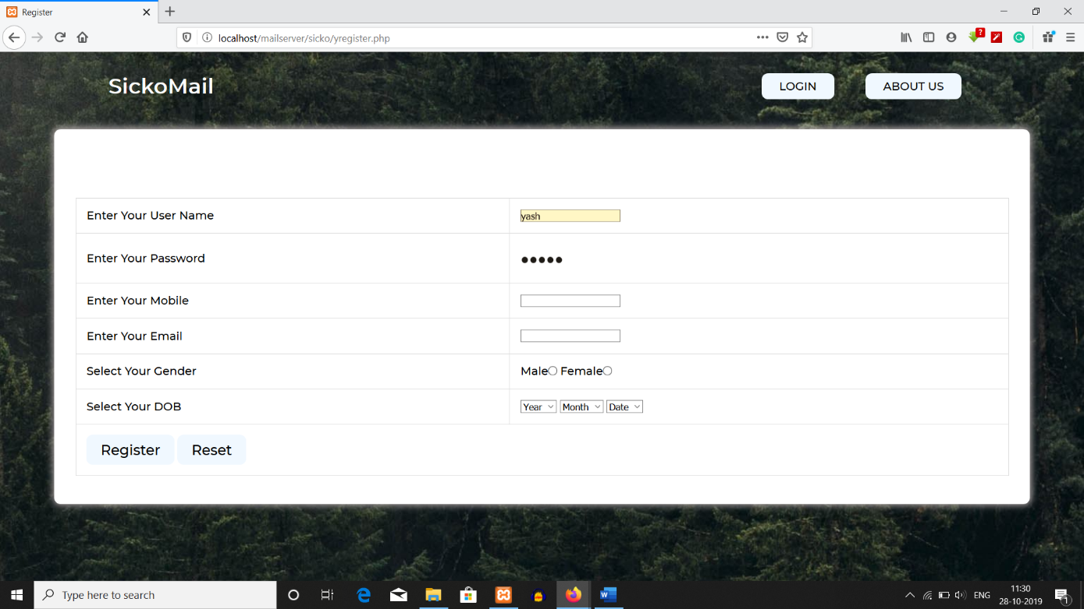

1. **Login Page**

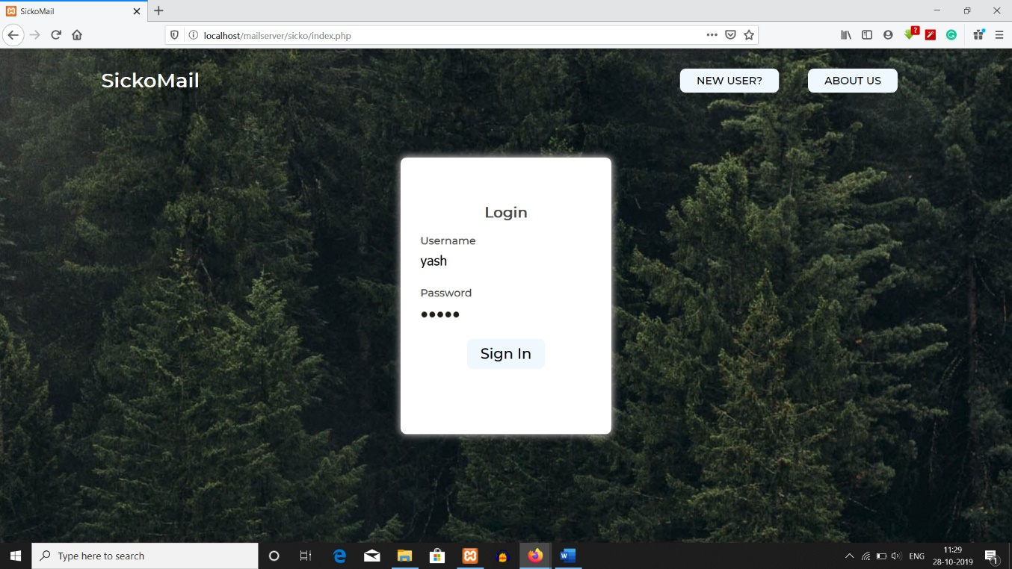

1. **Inbox**

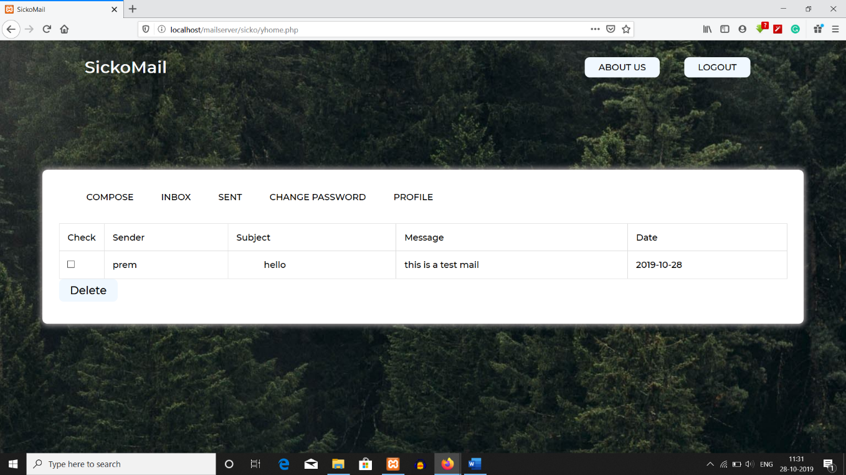

1. **Opened Mail**

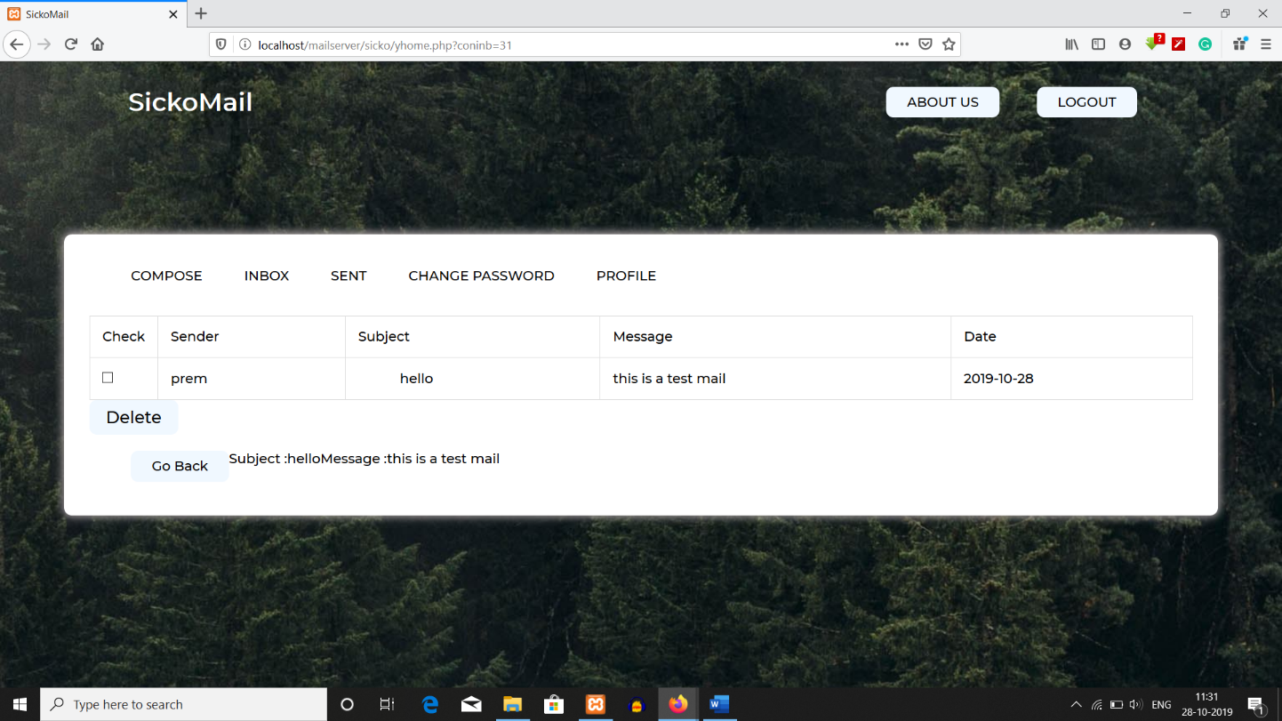

1. **Compose Mail**

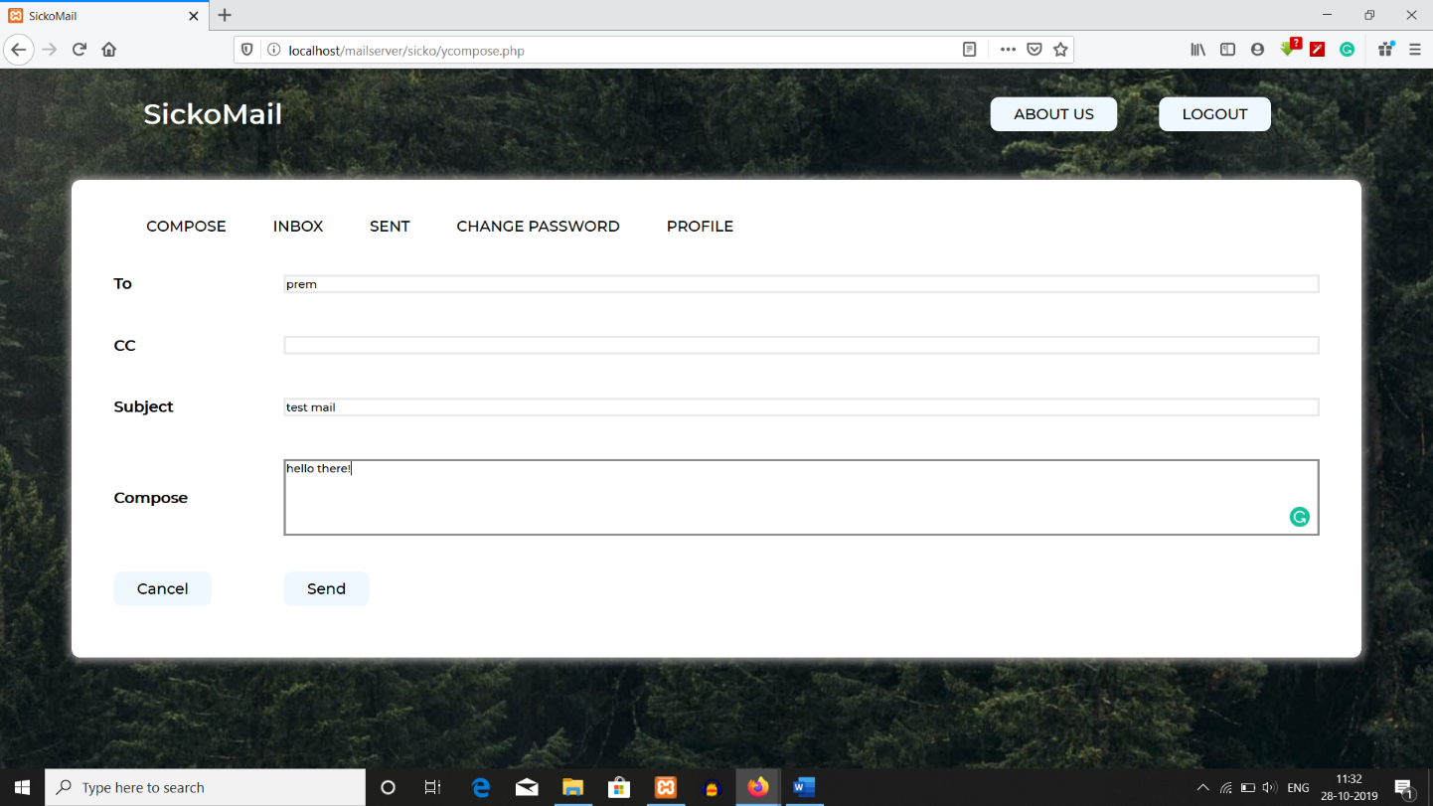

1. **Mail Sent Confirmation.**

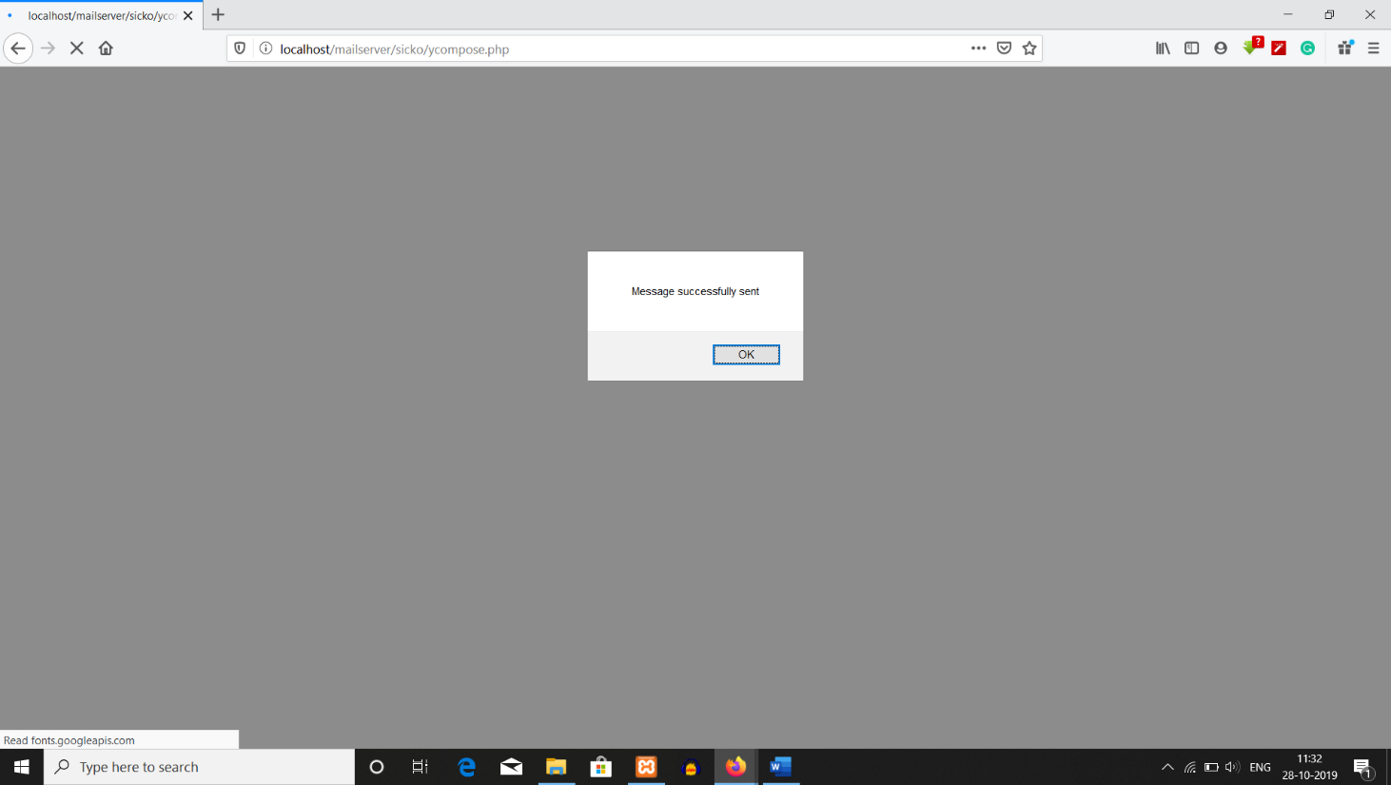

1. **Sent mail**

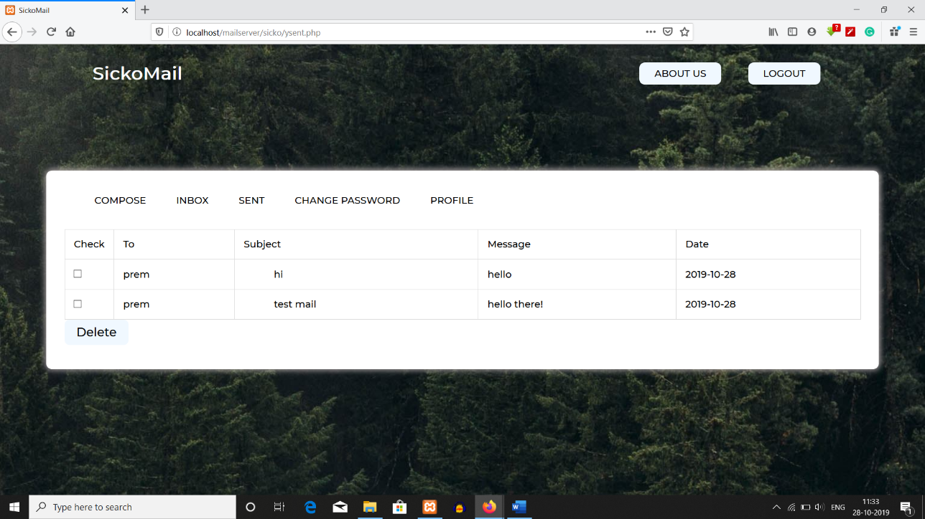

1. **Change Account Password**

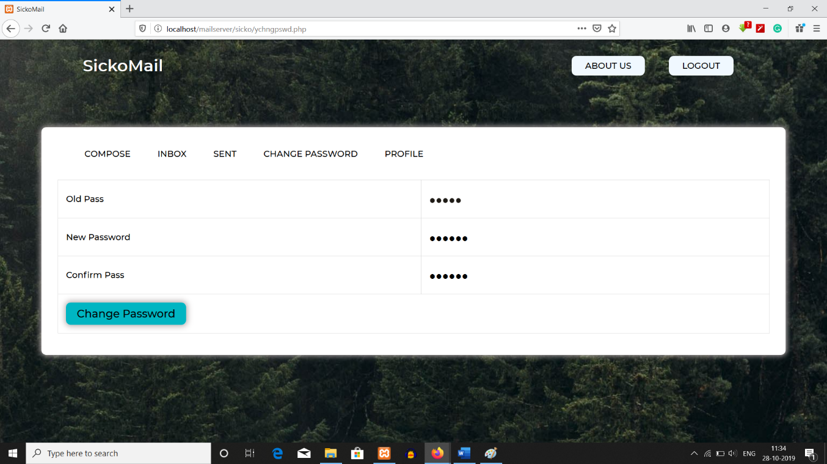

1. **View Profile**

